Ordinary Level Questions 2011

1.
The points P and Q lie on a straight level road.
A car passes P with a speed of 10 m s⁻¹ and accelerates uniformly for 6 seconds to a speed of 22 m s⁻¹ .
The car then decelerates uniformly to a speed of 18 m s⁻¹ and travels 80 m during this deceleration.
The car now maintains a constant speed of 18 m s⁻¹ for 3 seconds and then passes Q.
Find
- the acceleration
- the deceleration
- |PQ|, the distance from P to Q
- the average speed of the car, correct to one decimal place, as it moves from P to Q.

2.
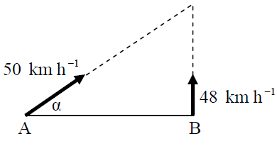
Ship A is 126 km due west of ship B.
A is moving at a constant speed of 50 km h⁻¹ in the direction east α north where tan α = $\frac{24}{7}$
B is moving due north at a constant speed of 48 km h⁻¹.
Find
- the velocity of A in terms of i and j
- the velocity of B in terms of i and j
- the velocity of A relative to B in terms of i and j.

Ship A intercepts ship B after t hours.
Find
- the value of t
- the distance each ship travels in this time t.

3.
A particle is projected from a point on horizontal ground with an initial speed of 58 m s⁻¹ at an angle β to the horizontal, where tan β = $\frac{20}{21}$.
- Find the initial velocity of the particle in terms of i and j.
- Calculate the time taken to reach the maximum height.
- Calculate the maximum height of the particle above ground level.
- Find the range.
- Find the two times at which the height of the particle is 75 m.

4.
(a)
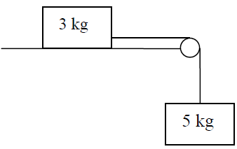
A particle of mass 3 kg is connected to a particle of mass 5 kg by a taut, light, inextensible string which passes over a smooth light pulley at the edge of a rough horizontal table.
The coefficient of friction between the 3 kg mass and the table is $\frac{2}{3}$.
The system is released from rest.
- Show on separate diagrams the forces acting on each particle.
- Find the common acceleration of the particles.
- Find the tension in the string.

(b)
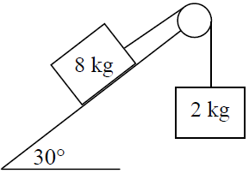
Masses of 8 kg and 2 kg are connected by a light inelastic string which passes over a smooth light pulley as shown in the diagram.
The 8 kg mass lies on a smooth plane which is inclined at 30⁰ to the horizontal.
The 2 kg mass hangs vertically.
The system is released from rest.
- Find the common acceleration of the masses.
- Find the tension in the string.

5.
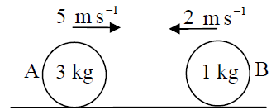
A smooth sphere A, of mass 3 kg, collides directly with another smooth sphere B, of mass 1 kg, on a smooth horizontal table.
Before impact A and B are moving in opposite directions with speeds of 5 m s⁻¹ and 2 m s⁻¹, respectively.
The coefficient of restitution for the collision is $\frac{1}{7}$ .
Find
- the speed of A and the speed of B after the collision
- the loss in kinetic energy due to the collision
- the magnitude of the impulse imparted to B due to the collision.

6.
(a)
Particles of weight 5 N, 8 N, 3 N and 1 N are placed at the points (4, 1), (–3, p), (p, q) and (15, 4), respectively.
The co-ordinates of the centre of gravity of the system are (1, p).
Find
- the value of p
- the value of q.
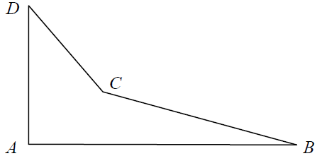
(b)
A quadrilateral lamina has vertices A, B, C and D.
The co-ordinates of the vertices are A(0, 0), B(18, 0), C(6, 3), D(0, 9).
Find the co-ordinates of the centre of gravity of the lamina.

7.
(a)
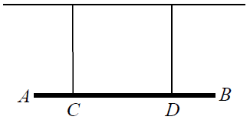
A uniform beam, AB, is held in a horizontal position by two vertical inelastic strings attached at points C and D respectively.
The weight of the beam is 45 N.
The length of the beam is 2 m.
A particle of weight 10 N is attached at A and a particle of weight 15 N is attached at B.
|AC| = |BD| = 0.5 m.
Calculate the tension in each of the strings.

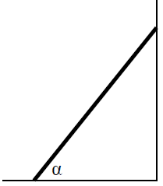
(b)
A uniform ladder, of weight 180 N, rests on rough horizontal ground and leans against a smooth vertical wall.
The length of the ladder is 6 m and the angle between the ladder and the ground is α, where tan α = $\frac{5}{12}$.
The ladder is in equilibrium and is on the point of slipping.
Find the coefficient of friction between the ladder and the ground.

8.
(a)
A particle describes a horizontal circle of radius 2 m with uniform angular velocity ω radians per second.
Its speed is 8 m s⁻¹.
Find
- the acceleration of the particle
- the time taken to complete one revolution.

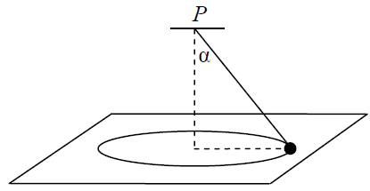
(b)
A smooth particle of mass 3 kg is attached by a light inelastic string to a fixed point P.
The particle describes a horizontal circle of radius 0·5 m on the smooth surface of a horizontal table.
The centre of the circle is vertically below P.
The string makes an angle α with the vertical, where tan α = $\frac{4}{3}$.
The speed of the particle is 2 m s⁻¹.
Find
- the tension in the string
- the reaction force between the particle and the table.
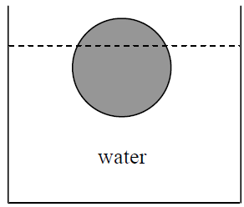

9.
(a)
A solid sphere, of radius 14 cm, floats at rest in water.
75% of the sphere lies below the surface of the water.
Find the weight of the sphere, correct to the nearest Newton.

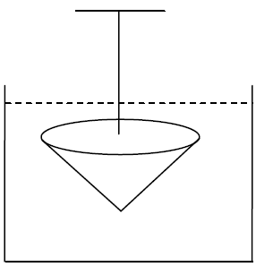
(b)
A solid cone of radius 10 cm and height 12 cm has relative density 7.
It is completely immersed in a liquid of relative density 0·9.
The cone is held at rest by a light inelastic vertical string which is tied to a fixed support.
The upper surface of the cone is horizontal.
Find the tension in the string, correct to the nearest Newton.
[Density of water = 1000 kg m⁻³].

